3GPP TSG-RAN WG1 Meeting #125 R1- 2604818
Dalian, China, May 18 – 22, 2026

Agenda Item: 10.8.3
Source: Ericsson
Title: Discussion on ISAC waveform and frame structure
Document for: Discussion, Decision

Introduction
The 6G radio study item describes the following (highlighted) objectives relating to the study of 6G sensing [1]:

SID:
The detailed objectives of the study are:
(9) Sensing – Studies to be based on use cases and associated requirements, as defined in [TR38.914]
- PHY functions and procedures for sensing technology (e.g., waveform. reference signals, measurement feedback, etc…) [RAN1, RAN4]
- Evaluate sensing performance and if necessary, extend channel modelling, for the selected use cases [RAN1]
- Aspects of integration with communication services [RAN1]
- higher layer procedures and protocol aspects [RAN2]
- RAN4 aspects of sensing including RF, coexistence, and testability in coordination with other WGs [RAN4]
Note: RAN1 identify detailed requirements, if triggered by TSG RAN

Note 1: Including proposals for potential enhancement based on communication waveform (e.g., low PAPR waveform enhancement, longer CP length, larger SCS etc.), potential new waveform, frame structure, and corresponding analysis on performance benefit and impact in terms of integration with communication.

General aspects on sensing modes
Rel-19 ISAC channel model supports all six sensing modes (i.e. TRP-TRP bistatic, TRP monostatic, TRP-UE bistatic, UE-TRP bistatic, UE-UE bistatic, UE monostatic). These modes require different RAN1 standardization efforts.
- TRP monostatic sensing mode: A single TRP serves as both sensing transmitter and receiver. Waveform, sensing signal design, signaling between sensing Tx and Rx, and all transmission/receiving details can be left to the base station implementation, so RAN1 standardization is not required to support this sensing mode.
- TRP-TRP bistatic sensing mode: Two distinct TRPs act as sensing transmitter and receiver. If both TRPs are from the same vendor, coordination of sensing transmission and reception can be handled by implementation. Sensing between TRPs from different vendors does require standardization efforts, but the use case is limited, for example at the boundary between two networks. In our view, the support of TRP-TRP bistatic sensing across different vendors is not needed for 6G Day1.
- UE monostatic sensing mode and UE-UE bistatic sensing mode: Although the TRP is not the sensing transmitter or receiver in these UE-only modes, the TRP still needs to configure radio resources for sensing signal transmission/reception and support measurement configuration and reporting over the Uu interface. These aspects (resource configuration and reporting) are therefore common specification impacts for both UE monostatic/UE-UE bistatic and UE-TRP/TRP-UE bistatic modes. Compared with UE monostatic, UE-UE bistatic sensing is expected to require considerable additional standardization effort (e.g., for coordinating two UEs for sensing and defining associated procedures), while concrete benefits and motivating use cases beyond what can be achieved with TRP-UE/UE-TRP sensing are not yet clear.
3GPP RAN1 work in LTE and NR focused on BS-UE interoperability. For 6G sensing studies, we therefore recommend that RAN1 focus on TRP-UE and UE-TRP bistatic sensing modes.
- The support of TRP monostatic mode and TRP-TRP bistatic sensing mode with TRPs from the same network vendor can be up to implementation and does not require RAN1 standardization.
- The usage of TRP-TRP bistatic sensing mode involving aNBs of different vendors is limited and not considered in 6G Day 1.
- Compared with UE monostatic, UE-UE bistatic sensing is expected to require considerable additional standardization effort (e.g., for coordinating two UEs for sensing and defining associated procedures), while concrete benefits and motivating use cases beyond what can be achieved with TRP-UE/UE-TRP sensing are not yet clear.
- For 6G sensing study, RAN1 prioritizes TRP-UE and UE-TRP bistatic sensing modes. Once the basic framework for TRP-UE and UE-TRP mode is accomplished, RAN1 can consider the necessary changes for UE-UE bistatic and UE monostatic modes.

ISAC waveform
When sensing is introduced as a new application of communication network, how to integrate sensing into communication (ISAC) is a fundamental question. There can be different levels of integration as shown in Figure 1. Reuse of communication waveform for sensing naturally allows the possibility of cost reduction by reusing hardware, spectrum, and TRP sites. In addition, using the same waveform for sensing and communication is the foundation of reuse of signal. Communication and sensing signals can be mapped to orthogonal time and frequence resources, enabling co-design of communication and sensing reference signals and data scheduling to optimize overall ISAC performance.
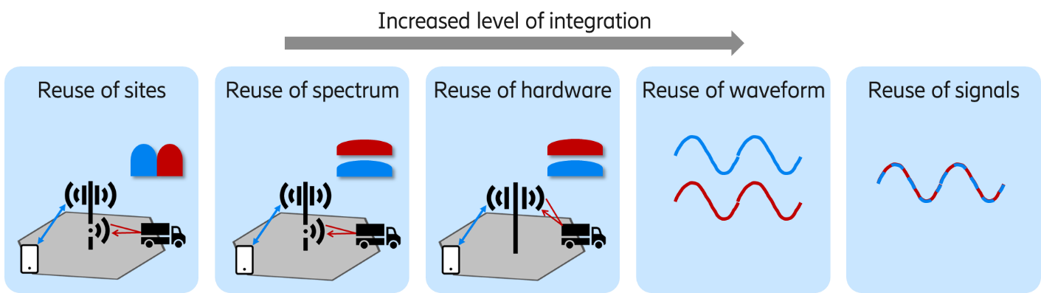
Figure 1 Different levels of integration between communication and sensing
RAN1 completed the Rel-20 NR sensing SI objectives in [3], including performance evaluation based on the existing DL NR waveform and DL NR reference signals as baseline assumptions. The study concluded that, for Baseline 1/2, using measurements from multiple (or all) TRPs allows 9/10 or 7/9 sources to meet the performance objectives [4]. This demonstrates that the NR CP-OFDM waveform can achieve the targeted sensing performance for the evaluated scenarios.
Based on what has been discussed, we have the following observations and a proposal.
- Reuse of communication waveform for sensing allows the possibility of cost reduction by reusing hardware, spectrum, and TRP sites. In addition, using the same waveform for sensing and communication is the foundation of reuse of signal.
- RAN1 study in Rel-20 NR sensing SI demonstrated that NR CP-OFDM waveform can achieve the targeted sensing performance objectives.
- Confirm CP-OFDM waveform as the baseline for 6G ISAC waveform.

3.1 Need for waveform standardization by sensing mode
In RAN1 #124b, there were many discussions regarding specifying waveforms for different modes as an enhancement to CP-OFDM waveform or as a separate waveform. In this section, we discuss the motivations for different waveforms needed for different modes.
- TRP monostatic/ UE monostatic: No interoperability requirement is needed across nodes or vendors because sensing transmission, reception, timing, and processing are all internal to one TRP or UE. Therefore, waveform and signal details can be left to implementation without affecting network-wide compatibility. A short-pulse waveform to improve sensing coverage is considered but we think that even though it may be beneficial (and even required) for some monostatic implementations, the choice can be left to TRP/UE implementation. Mandating a specific short-pulse waveform would constrain design options and may impose additional transmitter/receiver requirements (e.g., sampling rate, bandwidth occupancy, dynamic range) without adding interoperability value for this mode. Some companies mention the reason to study short pulse waveform as a general sensing waveform that is applicable to all sensing modes to reduce sensing overhead. This is also not necessary in our opinion. For example, using the same waveform for TRP-UE sensing is also not required. This is because, in many sensing geometries where the UE acts as the sensing receiver, the UE must be sufficiently close to the target/scatterer for useful echoes, limiting the generality of any “one-size-fits-all” waveform requirement. Hence, waveform selection can be left to implementation and use-case driven configuration. Short-pulse waveform contains much less energy than a symbol-duration based waveform leading to much less coverage of the short-pulse waveform for bistatic sensing (the advantage of short-pulse waveform is self-interference avoidance which is not an issue for bistatic sensing).
- TRP-TRP bistatic/multi-static: When two or more TRPs belong to the same vendor/network, coordination of sensing transmission/reception (including waveform choice, timing alignment, and processing assumptions) can be handled by implementation. In this case, specifying a common waveform in RAN1 does not add interoperability value.
  - In this context, “across vendors” refers to a scenario where the bistatic sensing transmit TRP and receive TRP are not under a single end-to-end baseband implementation (i.e., the two TRPs cannot assume aligned waveform generation, timing conventions, and receiver processing assumptions by design). A standardized waveform is primarily justified when interoperability is required between a sensing Tx-TRP and Rx-TRP that cannot rely on common proprietary design choices.
  - Same baseband vendor (including RU-only mix): If both TRPs are controlled by the same baseband vendor, waveform/RS design, timing alignment, and sensing processing assumptions can be coordinated by implementation. This remains true irrespective of whether the two TRPs use different RU vendors; RU differences mainly affect performance/feasibility, not interoperability. Hence, no RAN1 waveform mandate is needed.
  - Different Baseband vendors, but RU may be same or different vendors): This is the “across vendors” case that may require standardized solutions. Without a standardized waveform (or at least a constrained waveform set), the Rx-TRP cannot assume the Tx-TRP’s signal structure needed for robust correlation/matched filtering (e.g., time-frequency structure, reference signal properties, and associated receiver assumptions). This is therefore the main scenario that could motivate RAN1 waveform specification.
While cross-vendor TRP-TRP bistatic sensing could motivate waveform standardization, the use case is limited (e.g., inter-network boundary scenarios) and is not considered necessary for 6G Day 1. Therefore, for most deployments, RAN1 can avoid mandating a dedicated TRP-TRP bistatic waveform and instead focus on TRP–UE/UE–TRP interoperability; any cross-vendor TRP-TRP bistatic coordination can be deferred beyond 6G Day 1. The performance potential of a cross-vendor TRP-TRP solution is also limited by what kind of waveform options and information exchange has been standardized.
Even if TRP-TRP bistatic is specified (in intra or inter BS scenario), the key challenge for standardization is coordination (time/frequency synchronization, frame/resource alignment, and exchange of configuration/measurements), and specifically for the inter-aNB case. These aspects can be addressed via higher-level coordination mechanisms, and they do not inherently require mandating a single waveform.
- For 6G Day 1, RAN1 should not consider sensing mode-specific sensing waveforms or reference signals for TRP monostatic and TRP-TRP bistatic sensing, instead, leave the sensing waveform choice (limited to CP-OFDM-based enhancements) to implementation, and prioritize standardization where interoperability is required (TRP-UE/UE-TRP bistatic).

Evaluations of RSs and Waveforms
In the context of 6G ISAC evaluations, it is important to clarify the role and necessity of link-level simulations. While system-level simulations are essential for evaluating end-to-end sensing performance in realistic deployment scenarios, the relevance of link-level simulations depends on the specific evaluation objective.
For waveform and sensing reference signal design, evaluations can provide valuable insights into the fundamental properties of candidate sequences. Metrics such as Peak Sidelobe Level Ratio (PSLR), Integrated Sidelobe Level Ratio (ISLR), and ambiguity function characteristics are critical for understanding the resolution, detection accuracy, and side-lobe suppression capabilities of a given signal. These metrics are typically evaluated through analytical methods or simplified link-level simulations, rather than full simulations. Such evaluations are particularly relevant when comparing candidate sequences (e.g., Zadoff–Chu, Golay, m-sequences, or Gold sequences) and when assessing the impact of waveform shaping techniques (e.g., windowing) on sidelobe suppression and power efficiency through the ambiguity function. These analyses help determine the suitability of a waveform for detecting weak targets in cluttered environments and for achieving high range and velocity resolution.
Table 1: Signal-Level Metrics for Sensing Evaluation
Metric | Definition | Relevance to Sensing Performance
Peak Sidelobe Level Ratio (PSLR) | Ratio of the highest sidelobe amplitude to the main lobe amplitude in the ambiguity function. | Indicates the ability to suppress false detections caused by strong sidelobes. Lower PSLR improves target separability.
Integrated Sidelobe Level Ratio (ISLR) | Ratio of total sidelobe energy to main lobe energy in the ambiguity function. | Reflects robustness to clutter and interference. Lower ISLR improves detection of weak targets near strong reflectors.
Ambiguity Function Shape | 2D function of delay and Doppler shift showing matched filter response. | Determines resolution in range and velocity; affects ability to distinguish closely spaced targets.
Main Lobe Width | Width of the central peak in the ambiguity function. | Defines range and velocity resolution. Narrower main lobes enable finer localization.
Peak-to-Average Power Ratio (PAPR) | Ratio of peak signal power to average power. | Affects transmitter efficiency and dynamic range; relevant for practical implementation. Especially important for UL.

It is also worth noting that 3GPP TR 38.901, which serves as the baseline for link-level channel modelling in 5G NR, does not currently include a dedicated link-level channel model for ISAC. The existing models in TR 38.901 are designed for communication-centric evaluations and do not capture key aspects of sensing propagation, such as target reflections, radar cross-section (RCS), bistatic geometries, or extended targets. As a result, conventional link-level simulations based on TR 38.901 are not directly applicable to sensing evaluations. Developing a comprehensive ISAC-specific link-level channel model would require significant effort and is not currently within the scope of the 6G Study Item.
- The absence of a dedicated ISAC link-level channel model in TR 38.901 further limits the applicability of conventional link-level simulations for 6G sensing evaluations.
Given these considerations, we propose that link-level simulations are not required as a mandatory component of the 6G ISAC evaluation methodology in RAN1. Instead, signal-level evaluations should be conducted using analytical methods or targeted simulations to characterize ambiguity function behavior and side-lobe metrics such as PSLR, ISLR etc. These evaluations can be provided through individual contributions to support the selection of sensing reference signals. The primary focus of RAN1 evaluations should remain on system-level performance in the selected deployment scenarios, while signal-level analyses can serve as supporting evidence for reference signal design decisions.
- RAN1 agrees that no new ISAC link-level channel model needs to be considered for 6G sensing evaluations.
In RAN1 #124b[7], there was an agreement on the evaluations needed for waveform evaluation and ISAC operation.
Agreement:
Companies are encouraged to provide views on necessity/pros/cons/metrics of LLS and/or SLS and pros/cons/metrics of theoretical waveform characteristics analysis, for evaluation of ISAC waveform and/or integration with communication, to RAN1#125 meeting.
As mentioned above, analytical and simulation‑based evaluation of waveform properties such as ambiguity function (AF), peak side‑lobe ratio (PSLR), integrated side‑lobe ratio (ISLR), and peak‑to‑average power ratio (PAPR are fundamental to understanding sensing performance limits, mutual interference behavior, and hardware feasibility, and can be evaluated independently of detailed system‑level or link level simulations. The signal-level analysis which the agreement calls as “theoretical waveform characteristics analysis” provide early insights into waveform suitability for ISAC and integration with communication.
However, it is worthy to highlight different studies that may be needed for ISAC waveform suitability and integration with communication. These aspects are listed below.
1. CP‑OFDM with RX Windowing Only
For CP‑OFDM employing receiver‑side windowing only, RAN1 may study the theoretical ambiguity function characteristics, including main‑lobe shape, sidelobe behavior, PSLR and ISLR, under different receiver window designs. This allows quantification of the sensing performance impact of receive windowing without modifying the transmitted waveform.
The study should evaluate how RX windowing alters delay‑Doppler sidelobe levels and noise‑like behavior, and how this translates into detection and estimation performance indicators. Such analysis provides a clear baseline for CP‑OFDM‑based ISAC sensing and enables comparison against other windowing or waveform options without introducing transmitter‑side complexity.
2. CP‑OFDM with TX and RX Windowing
For CP‑OFDM employing both transmitter and receiver windowing, with the transmitter window assumed known at the receiver, RAN1 may study the resulting theoretical waveform characteristics, including ambiguity function, PSLR, and ISLR. In addition, the impact of transmitter windowing on spectral confinement and PAPR should be analyzed.
This study enables assessment of whether joint TX/RX windowing provides meaningful sidelobe suppression or sensing gain compared to RX‑only windowing, and under what assumptions. Where appropriate, this case may also serve as a bridge to discussing LLS‑type analytical metrics, provided the scope remains focused on waveform‑level behavior rather than full system simulation.
3. CP‑OFDM with Different Sequences (e.g., Zadoff‑Chu and Gold)
RAN1 may study CP‑OFDM using different underlying sequences (e.g., Zadoff‑Chu, Gold sequences) through theoretical ambiguity‑function‑based analysis, including PSLR and ISLR comparisons. This allows isolation of the impact of sequence properties on sensing sidelobes, range‑Doppler coupling, and robustness to interference, independent of higher‑layer scheduling or deployment assumptions.
Such a study is particularly useful to identify whether alternative sequences provide intrinsic sensing benefits (e.g., lower sidelobes or more favorable ambiguity function shapes) while remaining compatible with CP‑OFDM transmission.
4. CP‑OFDM Versus Other Waveforms
For comparison between CP‑OFDM and other candidate waveforms, RAN1 may study theoretical waveform characteristics as a minimum baseline, including ambiguity function, PSLR, ISLR, and PAPR. In addition, the study may include full SLS analysis to capture range‑Doppler behavior more comprehensively.
Beyond sensing metrics, the study should also consider impact on communication integration, including spectral efficiency implications, compatibility with existing NR/6G frame structures, implementation feasibility, and hardware capability constraints. CP‑OFDM should be used as the reference benchmark as agreed. Alternative waveforms shall only be considered if OFDM cannot fulfill the sensing requirements.
- Evaluation of CP-OFDM-based enhancements, including RX-only windowing, joint TX/RX windowing and different sequence designs, requires at least the study of theoretical waveform characteristics, including ambiguity function behavior, PSLR, ISLR, Doppler robustness, and PAPR.
- Comparing CP-OFDM with alternative waveforms requires considering not only sensing metrics but also system level evaluation of communication compatibility, implementation complexity, and overall integration feasibility.
- RAN1 agrees to study theoretical waveform characteristics analysis as a baseline and necessary component of ISAC waveform evaluation. The necessity of LLS and/or SLS can be considered further for different cases separately-
  - For Tx and Rx Windowing ,
  - For different RS sequences based on CP-OFDM enhancements,
  - For different waveforms other than CP-OFDM.

4.1 Evaluation of different RS sequences with and without windowing
Preliminary sequence evaluations have been carried out on selected sequences (Zadoff-Chu as adopted in SRS; Gold sequence as adopted in CSI-RS; Modified Zadoff-Chu & Quasi-Chirp[8]; and Enhanced Zadoff-Chu[9] relevant for TRP-UE and UE-TRP sensing topologies. Relevant metrics have been considered for the proposed sequence comparison.
It is worth noting that we have not simulated all sequence IDs within each group of sequences, but only one. This could have a different implication for PAPR and frequency error sensitivity. The adopted parameters are reported in Table 2.
Table 2: Sequences evaluation parameters
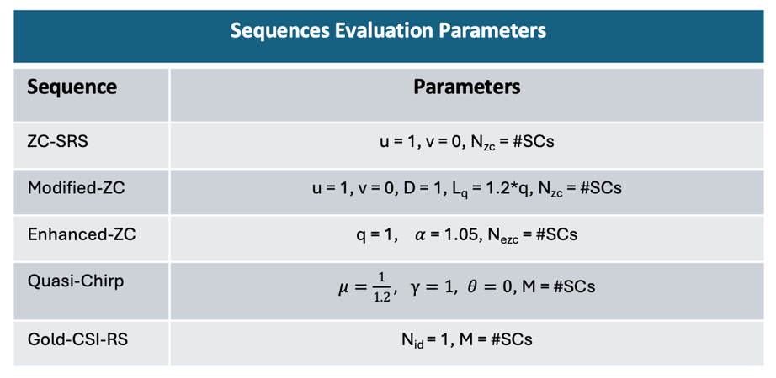
The evaluations assume a CP-OFDM framework and use the circular Autocorrelation Function (ACF) as the primary metric. Since all evaluated sequences have constant amplitude and are applied in the frequency domain with identical bandwidth, frequency windowing, and oversampling, the resulting ACF - in the absence of Doppler shift - depends solely on the applied window function. Specifically, the ACF reduces to the IFFT of the frequency-domain window. Thus, relevant differences are captured by the PAPR in general and the ACF when we have a Doppler frequency shift.
In the following figures, we show the ACF of all the studied sequencies without windowing. On the left figure, the ACF is depicted over all the delay length, while on the right figure, a zoom in version of the same ACF, but delimited within the ±100 ns delay interval range, is depicted.

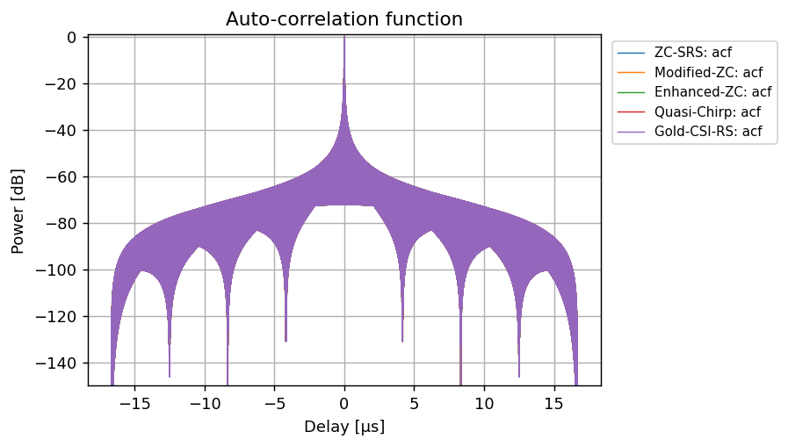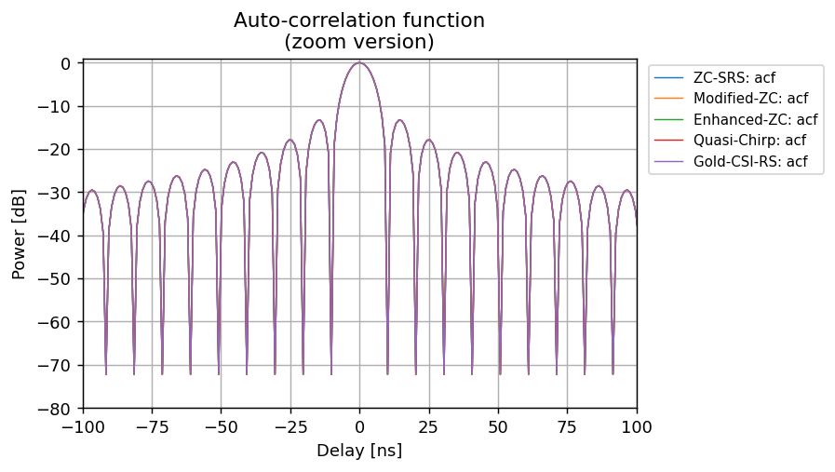
Figure 2 ACF of different sequencies without windowing.
In the following figures, we show the ACF of all the studied sequencies with Hamming windowing applied. On the left figure, the ACF is depicted over all the delay length, while on the right figure, a zoom in version of the same ACF, but delimited within the ±100 ns delay interval range, is depicted.
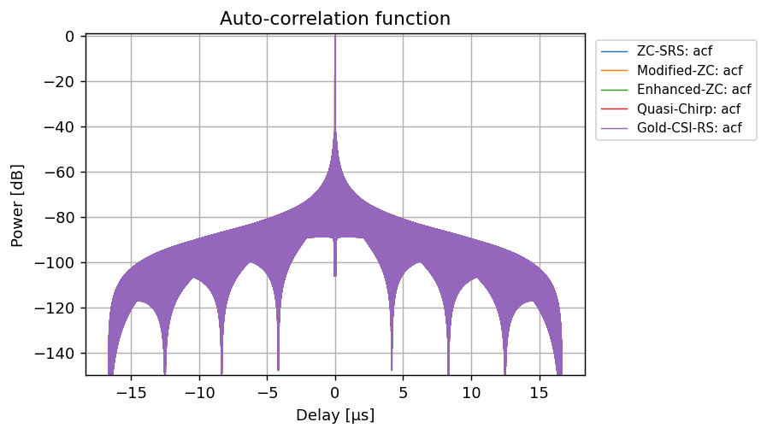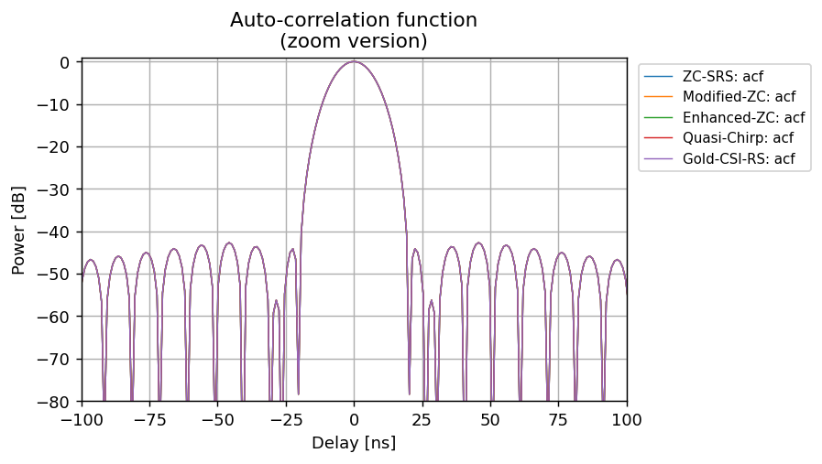
Figure 3 ACF of different sequencies with Hamming window applied.
Our evaluations highlight the differences in terms of PAPR [dB], computed in time domain, without windowing and with windowing (Hamming shaped window), as reported in
Table 3: PAPR comparison among sequences with and without windowing
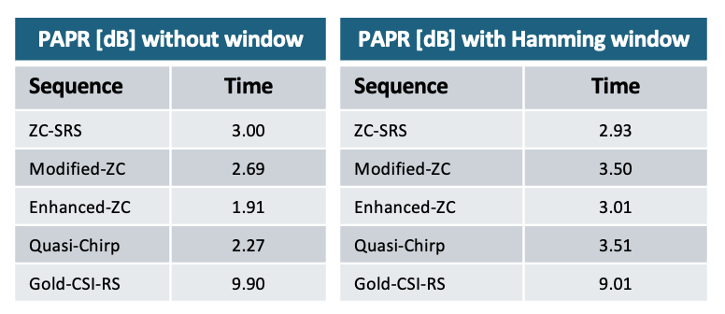
The PAPR analysis shows that without windowing, the Enhanced Zadoff-Chu seems to achieve the best PAPR, confirming the >1 dB reduction showcased in [9]. The Quasi-Chirp and Modified Zadoff-Chu follows, with higher PAPR values. When applying windowing (e.g. Hamming as in the proposed comparison) the newer proposed sequences cannot match the PAPR values achievable by the Zadoff-Chu used in SRS, although the Enhanced Zadoff-Chu remains close, in terms of PAPR values.
The PAPR results need to be interpreted together with the assumed windowing implementation. If windowing is applied at both transmitter and receiver, the impact on PAPR depends on the specific transmitter-side shaping that is used. By contrast, for receiver-only windowing, the transmitted signal is unchanged and the PAPR remains the same as in the no-windowing case. This distinction is important when comparing sequence candidates, since an observed PAPR increase may reflect the assumed TX/RX windowing realization rather than an intrinsic property of the underlying sequence itself.
- Tx windowing has an impact on the PAPR of the sequence.
In the following figures, we show the single ACF of each evaluated sequence with Hamming windowing applied and without any Doppler shift, as well as with a 500 Hz Doppler shift applied. The left side shows the full ACF, while the right side the zoom in version of the same ACF delimited within the ±100 ns delay interval range.

Zadoff-Chu (SRS) – Hamming windowing
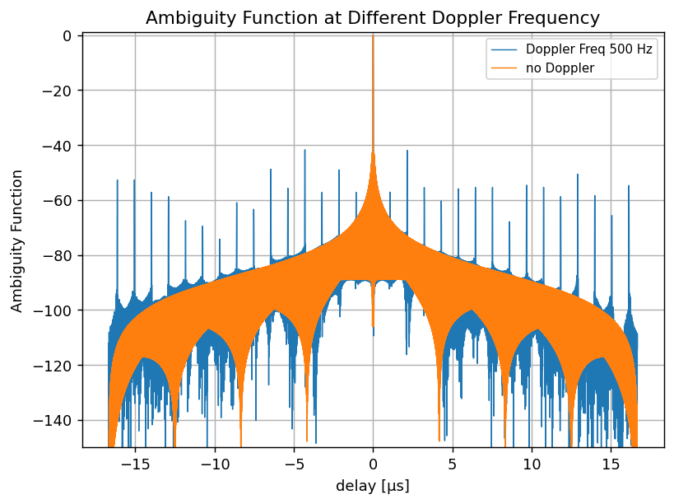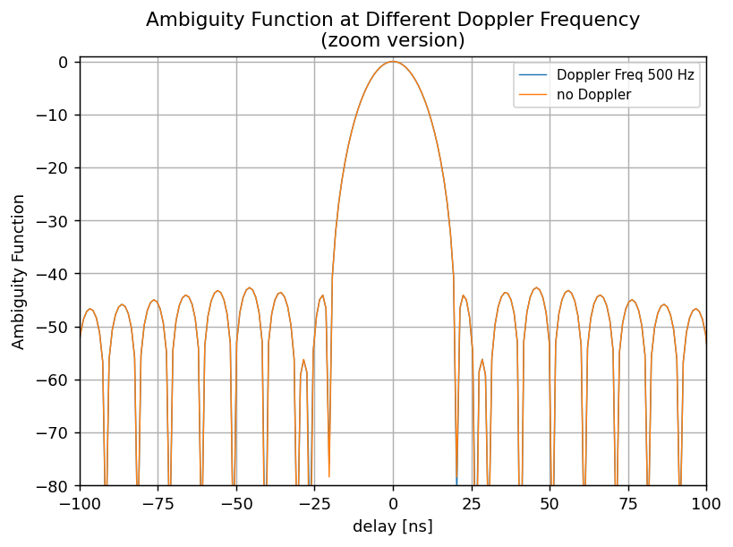
Modified Zadoff-Chu – Hamming windowing
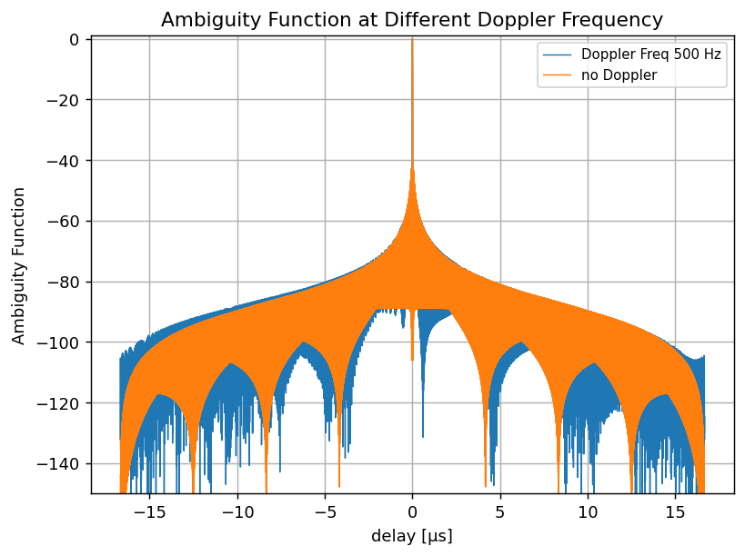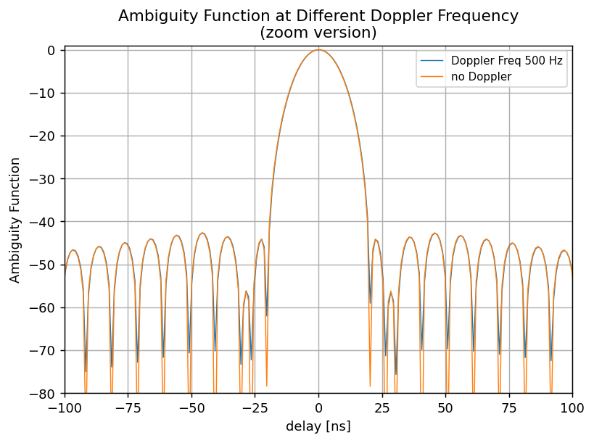
Enhanced Zadoff-Chu – Hamming windowing
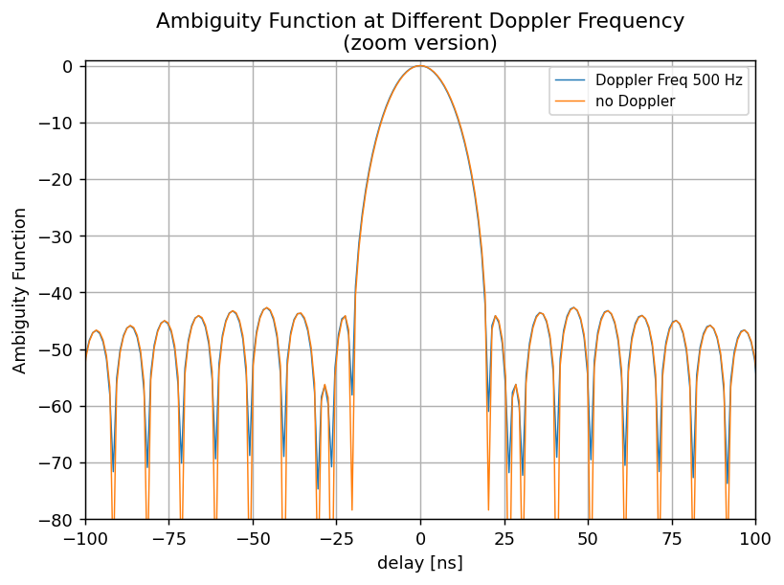
Quasi-Chirp – Hamming windowing
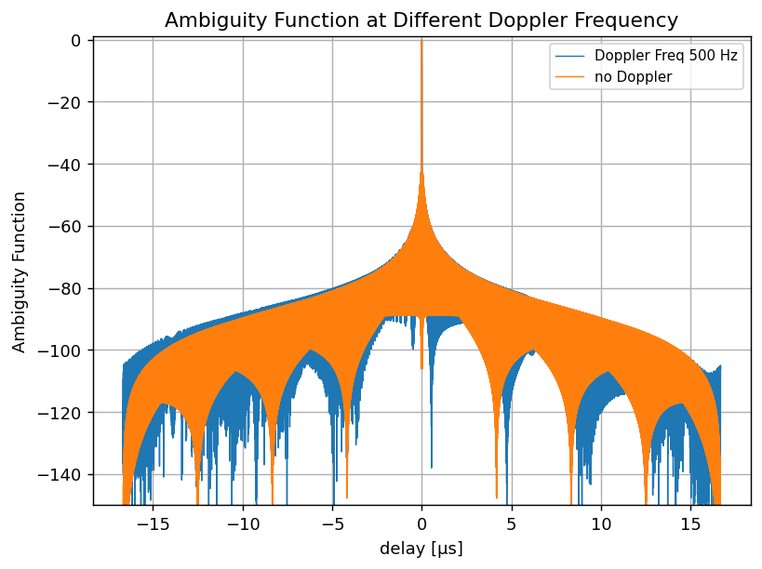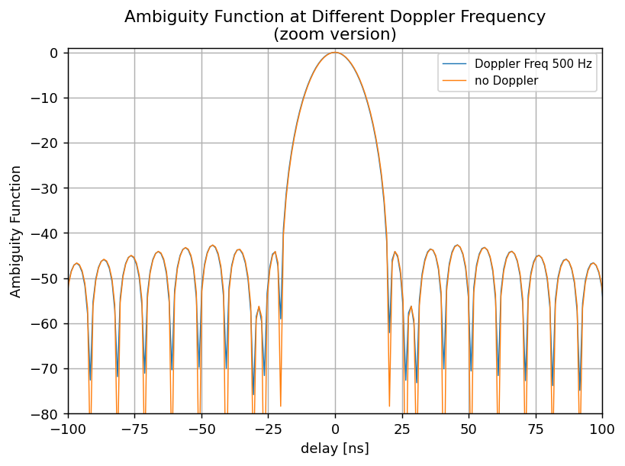
Gold CSI-RS – Hamming windowing
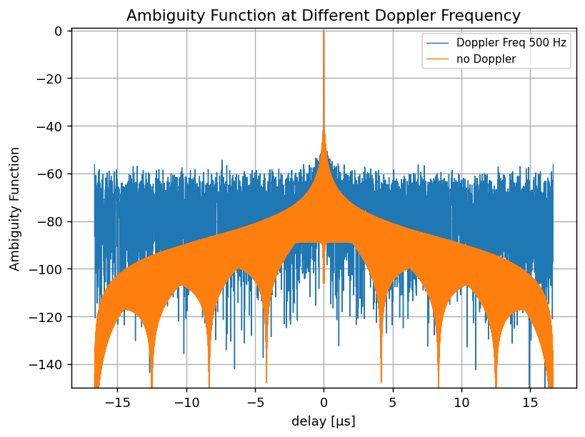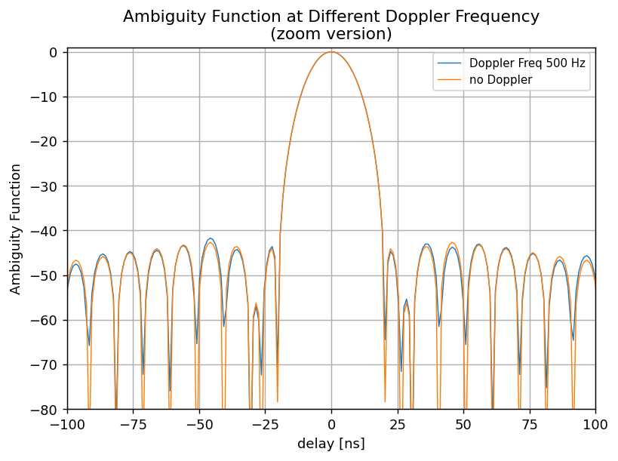
Figure 4 Delay cut of Ambiguity function of different sequences with Hamming window applied, with and without Doppler frequency (at 500 Hz)
The subcarrier spacing is 30 kHz for a system bandwidth of 100 MHz. The OFDM symbol duration is 32.33 μs and the NFFT size is 4096 samples. The sequence-specific parameters follow the definitions in [8] and [9].
As visible, the Enhanced Zadoff-Chu, the Quasi-Chirp and the Modified Zadoff-Chu have very similar behavior when subjected to a frequency error of 500Hz and show good resilience with very minor side-lobe growth. The Zadoff-Chu (SRS) and Gold CSI-RS have worse performance, with side-lobe growth.
- Based on the shown ACF results with a 500 Hz Doppler shift, Zadoff-Chu (SRS) and Gold CSI-RS exhibit more pronounced sidelobe growth and lower Doppler robustness than Enhanced Zadoff-Chu, Modified Zadoff-Chu, and Quasi-Chirp, which show more stable ambiguity characteristics under the same assumptions.
- For theoretical waveform-characteristics analysis of different RS sequences, RAN1 should evaluate both the zero-Doppler case and at least one non-zero Doppler condition.
- For theoretical waveform-characteristics analysis of different RS sequences, RAN1 should compare candidate sequences using ambiguity function behaviour, including PSLR, ISLR, and PAPR, and should account for the assumed windowing implementation.

Frame structure for ISAC
For TRP-UE bistatic sensing mode, sensing signal is transmitted by TRP to UE in the same way as a DL communication signal. Similarly, sensing signal is an UL signal for UE-TRP bistatic sensing mode. Using 6G communication frame structure is straightforward for the two sensing modes and can allow the tight coupling of sensing signal and communication signal in the same OFDM time-frequency resource grid.
OFDM readily supports large bandwidths, enabling fine range resolution and high positioning accuracy. However, sensing use cases differ in their requirements on maximum unambiguous range and maximum unambiguous velocity, which typically drive different choices for, bandwidth, pulse repetition interval, and sensing signal pattern. These diverse requirements can be addressed while retaining an CP-OFDM waveform by exploiting flexibility in configuring sensing reference signals in multiple ways (e.g., density, periodicity, time-frequency placement, etc.). Consequently, a single fixed reference signal configuration cannot simultaneously optimize all sensing scenarios; there is an inherent trade-off between sensing performance and the overhead required for the sensing signal.
- OFDM supports large bandwidths for fine range resolution and positioning accuracy. Diverse sensing requirements on maximum unambiguous range and velocity can be met by flexibly configuring sensing reference signals in multiple ways, while acknowledging an inherent trade-off between sensing performance and sensing-signal overhead.
- Reuse the communication frame structure and OFDM time-frequency resource grid for ISAC, enabling tight coupling of sensing and communication signals and flexible configuration of sensing reference signals to address diverse sensing requirements.
In our contribution [6], we provide a general frame structure that can be used for both communication and sensing. 6GR radio access networks will need to support a wide range of services and use cases across diverse UE capabilities. To enable harmonious coexistence within a cell, the frame structure should allow certain time-frequency resources to be reserved for specific purposes. For ISAC, this includes resources for sensing transmission and reception windows. For sensing, it may be desirable to make these resources accessible only to UEs that support the feature, while marking them as non-accessible for other UEs. A native mechanism to represent such reservations simplifies UE behaviour and can reduce unnecessary monitoring and power consumption. Therefore, we propose the following:
- For 6GR, study frame format configurations that incorporate an explicit “None” resource type to support flexible time-frequency resource reservation for ISAC and other services.
  - For TRP-UE and UE-TRP bistatic sensing, configure sensing reference signals on the “None” resources and signal the corresponding configuration only to UEs that support sensing.
  - For TRP monostatic and TRP-TRP bistatic sensing, the sensing signals can be handled by TRP implementation and therefore do not need to be configured to UEs if the sensing resources are configured in the “None” resources so that UEs can avoid those resources.

Conclusion
In the previous sections we made the following observations:
Observation 1 The support of TRP monostatic mode and TRP-TRP bistatic sensing mode with TRPs from the same network vendor can be up to implementation and does not require RAN1 standardization.
Observation 2 The usage of TRP-TRP bistatic sensing mode involving aNBs of different vendors is limited and not considered in 6G Day 1.
Observation 3 Compared with UE monostatic, UE-UE bistatic sensing is expected to require considerable additional standardization effort (e.g., for coordinating two UEs for sensing and defining associated procedures), while concrete benefits and motivating use cases beyond what can be achieved with TRP-UE/UE-TRP sensing are not yet clear.
Observation 4 Reuse of communication waveform for sensing allows the possibility of cost reduction by reusing hardware, spectrum, and TRP sites. In addition, using the same waveform for sensing and communication is the foundation of reuse of signal.
Observation 5 RAN1 study in Rel-20 NR sensing SI demonstrated that NR CP-OFDM waveform can achieve the targeted sensing performance objectives.
Observation 6 The absence of a dedicated ISAC link-level channel model in TR 38.901 further limits the applicability of conventional link-level simulations for 6G sensing evaluations.
Observation 7 Evaluation of CP-OFDM-based enhancements, including RX-only windowing, joint TX/RX windowing and different sequence designs, requires at least the study of theoretical waveform characteristics, including ambiguity function behavior, PSLR, ISLR, Doppler robustness, and PAPR.
Observation 8 Comparing CP-OFDM with alternative waveforms requires considering not only sensing metrics but also system level evaluation of communication compatibility, implementation complexity, and overall integration feasibility.
Observation 9 Tx windowing has an impact on the PAPR of the sequence.
Observation 10 Based on the shown ACF results with a 500 Hz Doppler shift, Zadoff-Chu (SRS) and Gold CSI-RS exhibit more pronounced sidelobe growth and lower Doppler robustness than Enhanced Zadoff-Chu, Modified Zadoff-Chu, and Quasi-Chirp, which show more stable ambiguity characteristics under the same assumptions.
Observation 11 OFDM supports large bandwidths for fine range resolution and positioning accuracy. Diverse sensing requirements on maximum unambiguous range and velocity can be met by flexibly configuring sensing reference signals in multiple ways, while acknowledging an inherent trade-off between sensing performance and sensing-signal overhead.

Based on the discussion in the previous sections we propose the following:
Proposal 1 For 6G sensing study, RAN1 prioritizes TRP-UE and UE-TRP bistatic sensing modes. Once the basic framework for TRP-UE and UE-TRP mode is accomplished, RAN1 can consider the necessary changes for UE-UE bistatic and UE monostatic modes.
Proposal 2 Confirm CP-OFDM waveform as the baseline for 6G ISAC waveform.
Proposal 3 For 6G Day 1, RAN1 should not consider sensing mode-specific sensing waveforms or reference signals for TRP monostatic and TRP-TRP bistatic sensing, instead, leave the sensing waveform choice (limited to CP-OFDM-based enhancements) to implementation, and prioritize standardization where interoperability is required (TRP-UE/UE-TRP bistatic).
Proposal 4 RAN1 agrees that no new ISAC link-level channel model needs to be considered for 6G sensing evaluations.
Proposal 5 RAN1 agrees to study theoretical waveform characteristics analysis as a baseline and necessary component of ISAC waveform evaluation. The necessity of LLS and/or SLS can be considered further for different cases separately-
1) For Tx and Rx Windowing ,
2) For different RS sequences based on CP-OFDM enhancements,
3) For different waveforms other than CP-OFDM.
Proposal 6 For theoretical waveform-characteristics analysis of different RS sequences, RAN1 should evaluate both the zero-Doppler case and at least one non-zero Doppler condition.
Proposal 7 For theoretical waveform-characteristics analysis of different RS sequences, RAN1 should compare candidate sequences using ambiguity function behaviour, including PSLR, ISLR, and PAPR, and should account for the assumed windowing implementation.
Proposal 8 Reuse the communication frame structure and OFDM time-frequency resource grid for ISAC, enabling tight coupling of sensing and communication signals and flexible configuration of sensing reference signals to address diverse sensing requirements.
Proposal 9 For 6GR, study frame format configurations that incorporate an explicit “None” resource type to support flexible time-frequency resource reservation for ISAC and other services.
1) For TRP-UE and UE-TRP bistatic sensing, configure sensing reference signals on the “None” resources and signal the corresponding configuration only to UEs that support sensing.
2) For TRP monostatic and TRP-TRP bistatic sensing, the sensing signals can be handled by TRP implementation and therefore do not need to be configured to UEs if the sensing resources are configured in the “None” resources so that UEs can avoid those resources.

References
- RP-251881, New SID: Study on 6G Radio, NTT Docomo, RAN#108, Prague, Czech Republic, June 2025.
- TR 38.901, Study on channel model for frequencies from 0.5 to 100 GHz, RAN#111, March 2026
- RP-253246, Xiaomi, China Telecom, Revised SID: Study on Integrated Sensing And Communication (ISAC) for NR, RAN#110, December 2025
- TR 38.765, Study on Integrated Sensing And Communication (ISAC) for NR, RAN#111, March 2026
- R1-2602476, Discussion on Evaluations for 6G Sensing, Ericsson, April 2026
- R1-2601876, 6G general aspects and frameworks, Ericsson, April 2026
- R1-2602985, Final FL Summary on 10.8.3 ISAC WF, Moderator (LGE), RAN1 #124bis, April 2026
- R1-2602205, Discussion on waveform and frame structure, Samsung, RAN1#124bis, April 2026.
- R1-2603032, Waveforms sensing for 6GR air interface, Qualcomm Incorporated , RAN1#124bis, April 2026.

